St. James United Church
United in Faith
Strengthened by Friendship
Building a Community of Love and Justice

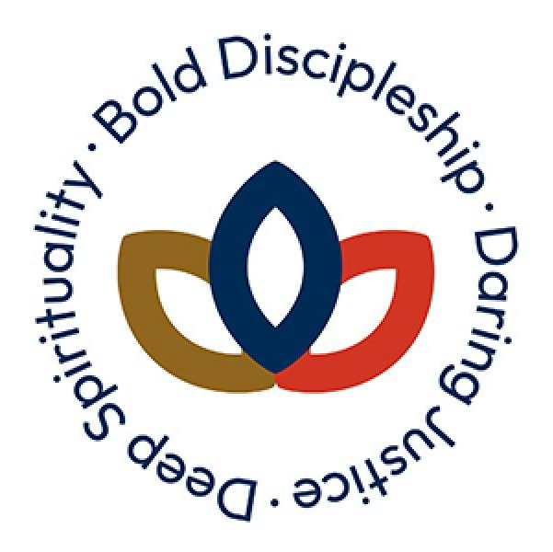

June 25, 2023 @ 10:00 am


181 Portland Street
Dartmouth
B2Y 1J5
902-464-8852

▲Rise in body or in spirit/ Responses in bold

Gathering Music

Welcome & Introductions

Crossing the Threshold Into Worship

Lighting the Christ and Pride Candles

▲Sung Celebration Song – Come, O Spirit # 198 V1 (Tune # 559)

Come, O Spirit, dwell among us, come with pentecostal power;
give the church a stronger vision, help us face each crucial hour.
Built upon a firm foundation, Jesus Christ, the cornerstone,
still the church is called to mission, that God's love shall be made known.

Call to Worship

We are called by God.
We are disciples of Jesus
We seek to be a people of deep spirituality,
We come, wanting to be bold, diverse, connected and evolving.
We dare to dream of a better world.
A world of justice for all.
Come, let us worship!

Opening Prayer (Together)

Uniting God,
you have called us from across oceans
and throughout time, to be the church.
Give us the courage, humility and grace
to humbly accept this call, at this time.
Forgive us our zeal, when we are overly deep, bold, and daring,
slow and steady us so that we may consider how our piety, discipleship and witness affects those around us,
and best embody the way and teachings of Christ in the world.
Guide and support us when the journey is treacherous,
when the mountains are too high and the valleys are too low,
so that for your sake, and by your grace we will be able to:
Dwell deeper in our connection to you and to each other;
Grow bolder in our commitment to your son and his way; and
Be daring in our prayer, praise, and practice.
May all glory be yours, now and forever, Amen.

▲Opening Hymn – The Church’s One Foundation # 331

Deep Spirituality

Reflection

▲Hymn – I, the Lord of Sea and Sky # 509

Bold Discipleship: Following Jesus

Prayer of Confession

Almighty and most merciful companion,
we have erred, and strayed from thy ways like lost sheep.
we have followed too much the devices and desires
of our own hearts and prejudices.
We have offended against Thy holy laws …
We have left undone those things which we ought to have done
…time of silence…
And we have done those things which we ought not have done
…time of silence…
And there is no health in us.
But Thou, O God, have mercy upon us,
and our miserable offenses.
We who confess our faults, spare us, O God.
We who are penitent, restore us, O God.
According to your promise declared to humankind in Christ Jesus,
the sovereign, deliver us.
And grant, O most Merciful One, for Christ’s sake,
that we may hereafter live a better and good life;
to the glory of Thy Holy Name.
Amen

Ministry of Music – I Know Who Holds Tomorrow

Reflection – Jennifer Adams

▲Hymn – Jesus, You Have Come to the Lakeshore # 563

Daring Justice

Reflection – Debra Keays-White

▲Hymn – The Day Thou Gavest, Lord is Ended # 438

The Sacrament of Holy Communion

Telling the Story

Prayers of the People & The Lord’s Prayer

Let us continue to pray,
concluding each petition with a call:
God, receive our prayers; and response: And in your love answer.

We pray with the words that Jesus taught his first followers,
“Our Father…

Communion is Served:
Gluten free bread and juice will be served in the pews.
When you receive them, hold on to them,
and we will eat and drink together.

While communion is being served, we will sing # 466

Eat this bread, drink this cup;
come to me and never be hungry.
Eat this bread, drink this cup;
trust in me and you will not thirst.

Prayer following Communion

The Life and Ministry of the Faith Community

Threshold Into God’s World

▲Hymn – Go to the World # 420

▲Commissioning & Blessing

▲Song of Dismissal – Come, O Spirit # 198 – V2 (Tune # 559)

We would raise our hallelujahs, for the grace of yesteryears;
for tomorrow's unknown pathway, hear, O God, our humble prayers.
In the church's pilgrim journey, you have led us all the way,
still in presence move before us, fire by night and cloud by day.

Music Takes Us into the World

Call to Worship -Catherine MacDonald
Liturgy – United Church of Canada

