St. James United Church
United by Faith
Strengthened by Friendship
Building a Community of Love and Justice

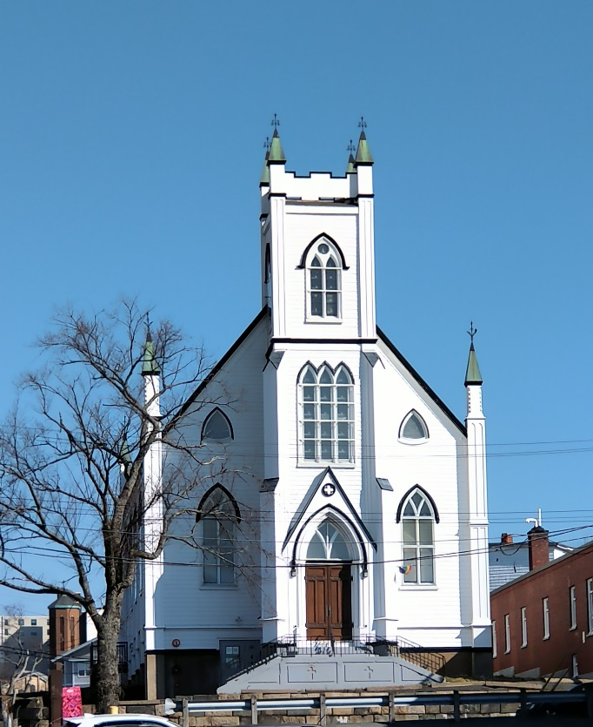

June 11, 2023 @ 10:00 am

181 Portland Street
Dartmouth
B2Y 1J5
902-464-8852

▲Rise in body or in spirit/ Responses in bold

Gathering Music

Welcome and Introductions

Crossing the Threshold Into Worship

Lighting the Christ and Pride Candles

▲Sung Celebration Song – Come, O Spirit # 198 V1 (Tune # 559)

Come, O Spirit, dwell among us,
come with pentecostal power;
give the church a stronger vision,
help us face each crucial hour.
Built upon a firm foundation,
Jesus Christ, the cornerstone,
still the church is called to mission,
that God's love shall be made known.

Call to Worship

We are the body of Christ
Baptized in one Spirit, we are members of one body
Many and varied in gender, colour, sexuality, age, class and ability, we are members of Christ’s body
None of us can say to one another “I have no need of you”
For only together can we find wholeness
None of us can say to another “I will not care for you”
For we are all connected like muscle and bone
If one suffers, we all suffer. If one rejoices, we all rejoice,
Thanks be to God, who, in Christ, has made us one
Let us worship God

Opening Prayer…. in unison

As we make decisions for the future
We ask that your Holy Spirit enable us,
to act not out of selfish ambition or conceit
but in humility to regard others as better than ourselves,
Help each of us to look not to our own interests
but the interests of others
and ultimately to glorify you. Amen

▲Opening Hymn – Morning has Broken # 409

Listening for God’s Word For Us Today

A New Creed. Page # 918

We are not alone;
we live in God’s world.

We believe in God:
who has created and is creating,
who has come in Jesus,
the Word made flesh,
to reconcile and make new,
who works in us and others
by the Spirit.

We trust in God.

We are called to be the Church:
to celebrate God’s presence,
to live with respect in Creation,
to love and serve others,
to seek justice and resist evil,
to proclaim Jesus, crucified and risen,
our judge and our hope.
In life, in death, in life beyond death,
God is with us.
We are not alone.

Thanks be to God.

Scripture and Reflection

Philippians 2: 1-5

Reflective Music

Responding to God’s Word

Minute for Mission

Announcements

▲Hymn – Sing Your Joy # 253

Prayers of the People

Threshold Into God’s World

▲Hymn – Lead on, O Cloud of Presence # 421

Commissioning and Blessing

▲Song of Dismissal – Come, O Spirit # - V2

We would raise our hallelujahs
for the grace of yesteryears
for tomorrow’s unknown pathway
hear, O God, our humble prayers
In the church’s pilgrim journey
you have led us all the way,
still in presence move before us,
fire by night and cloud by day

Music Takes Us into the World



