St. James United Church

Pentecost!

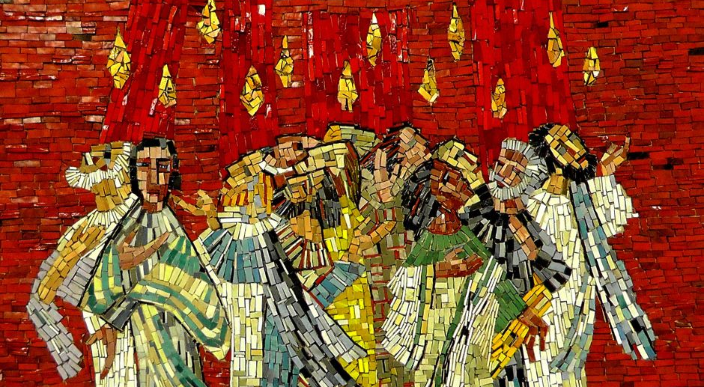

May 28, 2023 @ 10:00 am


181 Portland Street
Dartmouth
B2Y 1J5
902-464-8852

▲Rise in body or in spirit/ Responses in bold

Gathering Music

▲Sung Celebration Hymn – Come, O Holy Spirit

Come, O Holy Spirit, set the Church on fire;
strike it as the lightning hits a posing spire.
Burn away the structures and
consume the sham of our holy systems:
Come, in Jesus’ name!

Come, come, come,
in Jesus’ name!
Take our hearts by storm.
All the world lies open
Pentecost is now!

I said a - Come, come, come,
in Jesus’ name!
Take our hearts by storm.
All the world lies open
Pentecost is now!

2 Blow away the cobwebs of our stubborn past.
Come, send flying from us myths unfit to last.
Wind of change, refresh us and disturb our calm;
teach us what true love is,
take our hearts by storm.

Come, come, come,
in Jesus’ name!
Take our hearts by storm.
All the world lies open
Pentecost is now!

I said a - Come, come, come,
in Jesus’ name!
Take our hearts by storm.
All the world lies open
Pentecost is now!

3 Free us from the babble of our Babel mind;
spark in us a language all can understand.
Lighten then our darkness,
Come and show us how all the world lies open:
Pentecost is now!

Come, come, come,
in Jesus’ name!
Take our hearts by storm.
All the world lies open
Pentecost is now!

I said a - Come, come,
come, in Jesus’ name!
Take our hearts by storm.
All the world lies open
Pentecost is now!

Welcome & Introductions

Lighting the Christ and Pride Candles

Call to Worship

We come in faith.
We come in friendship.
We persevere through teamwork.
We rejoice in community.
We come, thankful for kindness.
We come, delighted to be together once again.
Come, let us worship!

Opening Prayer (Together)

Come, Holy Spirit,
breathe into our hearts the holy fire of change:
sparks of resiliency, improvisation, innovation, and ingenuity. See our talents flare with holy energy!
Give us wings of piping-hot courage.
Ignite our tongues with compassionate words
in burning confrontation and refusal of all evil.
Fill our souls with flames of inclusive love
as we reach out to others,
enveloping us all in glowing coals of acceptance.
Then, grant us lasting embers of strength and faith
to embrace the new world of your creation.

Silent Prayer…

We turn to you,
knowing that you understand us,
forgive us, and love us like a Mother,
and so we pray with confidence and faith,
“Our Father, who art in heaven,
hallowed be thy name; thy kingdom come;
thy will be done; on earth as it is in heaven.
Give us this day our daily bread.
And forgive us our trespasses,
as we forgive those who trespass against us.
And lead us not into temptation;
but deliver us from evil. For thine is the kingdom,
the power and the glory,
for ever and ever. Amen.
Listening for God’s Word For Us Today

A Time of Wondering

Transitions – Luke Fage

An Ancient Word – Acts 21: 1-21

Reflection – Tongues of Fire

Reflective Music

Responding to God’s Word

▲Hymn – Spirit, Spirit of Gentleness # 375

▲A New Creed – Page # 918

Minute for Mission

Sharing Our Gifts

Prayers of the People

The Life and Ministry of the Faith Community – Please See Insert

Threshold Into God’s World

▲Hymn – God the Spirit, Guide and Guardian # 514

▲Commissioning & Blessing

▲Song of Dismissal – Come, O Spirit # 198 – V2

We would raise our hallelujahs
for the grace of yesteryears;
for tomorrow's unknown pathway,
hear, O God, our humble prayers.
In the church's pilgrim journey
you have led us all the way,
still in presence move before us,
fire by night and cloud by day.

Music Takes Us into the World

Call to Worship -Catherine MacDonald – Based on Core Values Workshop – April 2023
Opening Prayer – Jani Francis, St. Andrew's U.C., Indian Head, Sask.

