St. James United Church

Easter Series: Unearthing Joy

Keeping Joy Alive

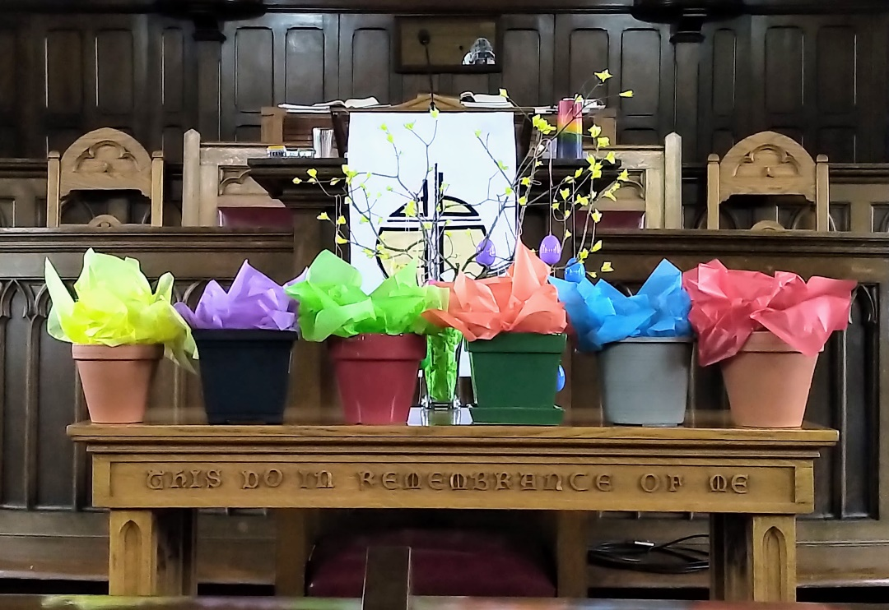

May 21, 2023 @ 10:00 am
Ascension Sunday


181 Portland Street
Dartmouth
B2Y 1J5
902-464-8852

▲Rise in body or in spirit/ Responses in bold

Gathering Music

Welcome & Introductions

Crossing the Threshold Into Easter

Lighting the Christ and Pride Candles

Sung Celebration – Rejoice in the Lord, Always # 249 (Twice)

Rejoice in the Lord always
and again I say rejoice! (clap, clap)
Rejoice in the Lord always
and again I say rejoice! (clap, clap)
Rejoice, rejoice,
and again I say rejoice! (clap, clap)
Rejoice, rejoice,
and again I say rejoice! (clap, clap)

Call to Worship

We come in faith.
We come in friendship.
We persevere through teamwork.
We rejoice in community.
We come, thankful for kindness.
We come, delighted to be together once again.
Come, let us worship!

▲Hymn – Open My Eyes # 371

Opening Prayer (Together)

Creator of all things, we come into your presence,
marvelling at the mystery of life and death and life again.
On this Ascension Sunday, as Jesus left his friends,
and left his mission in their hands,
we know that his mission is now in our hands.
Inspire us to carry on that mission that is summed up in
“Love God and love your neighbour as yourself.”

Silent Prayer…

We turn to you,
knowing that you understand us,
forgive us, and love us like a Mother,
and so we pray with confidence and faith,
“Our Father, who art in heaven,
hallowed be thy name; thy kingdom come;
thy will be done; on earth as it is in heaven.
Give us this day our daily bread.
And forgive us our trespasses,
as we forgive those who trespass against us.
And lead us not into temptation;
but deliver us from evil.
For thine is the kingdom,
the power and the glory,
for ever and ever.
Amen.

Listening for God’s Word For Us Today

A Time of Wondering

An Ancient Word – Luke 24: 44-53

Reflection – Great Joy!

Reflective Music

Responding to God’s Word

▲Hymn – This is God’s Wondrous World # 296

▲A New Creed – Page # 918

Minute for Mission

Sharing Our Gifts

Prayers of the People

The Life and Ministry of the Faith Community – Please See Insert

Threshold Into God’s World

▲Hymn – Come Touch Our Hearts

- Come touch our hearts that we may know compassion,
from failing embers build a blazing fire;
love strong enough to overturn injustice,
to seek a world more gracious, come touch and bless our hearts.

2 Come touch our souls that we may know and love you,
your quiet presence all our fears dispel;
create a space for spirit to grow in us,
let life and beauty fill us, come touch and bless our souls.

3 Come touch our minds and teach us how to reason,
set free our thoughts to wonder and to dream;
help us to open doors of understanding,
to welcome truth and wisdom, come touch and bless our minds.

4 Come touch us in the moments we are fragile,
and in our weakness your great strength reveal;
that we may rise to follow and to serve,
steady now our nerve, come touch and bless our wills.

▲Commissioning & Blessing

▲Song of Dismissal – Onward Easter People

Onward Easter people, risen with our Lord.
Loving, caring, sharing, spread his living Word.
Death no longer holds him, we can plainly see.
Christ is resurrected, we have been set free.
Onward Easter people, risen with our Lord.
Loving, caring, sharing, spread his living Word.

Music Takes Us into the World
Please note, our services are livestreamed
and photographs may be taken.
Call to Worship -Catherine MacDonald – Based on Core Values Workshop – April 2023
Opening Prayer – Catherine MacDonald
Onward Easter People – Catherine MacDonald

