St. James United Church

Easter Series: Unearthing Joy

The Joy of Companionship

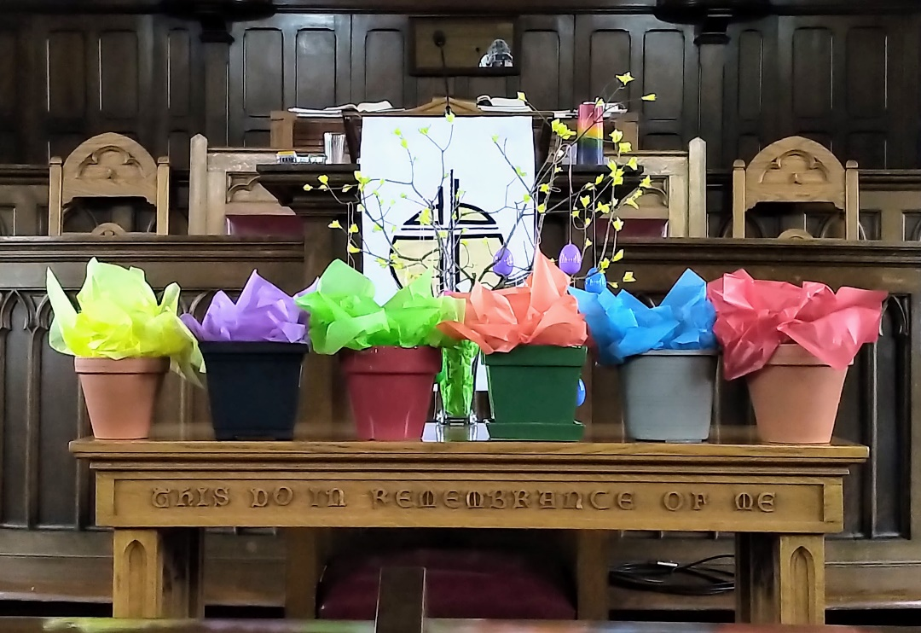

April 30, 2023 @ 10:00 am


181 Portland Street
Dartmouth
B2Y 1J5
902-464-8852

▲Rise in body or in spirit/ Responses in bold

Gathering Music

Welcome & Introductions

Crossing the Threshold Into Easter

Lighting the Christ and Pride Candles

Sung Celebration – Rejoice in the Lord, Always # 249 (Twice)

Rejoice in the Lord always
and again I say rejoice! (clap, clap)
Rejoice in the Lord always
and again I say rejoice! (clap, clap)
Rejoice, rejoice,
and again I say rejoice! (clap, clap)
Rejoice, rejoice,
and again I say rejoice! (clap, clap)

Call to Worship

Come to this place with open minds and open hearts.
We leave our prejudices and biases at the door.
This is a place where we look deep within ourselves,
prepared to let the Spirit shape us
into the people God calls us to be.
Come and prepare to be changed.
With every whisper of God, we are transformed.
Let us worship God as we come together.

▲Hymn – God, Who Gives to Life Its Goodness # 260

Opening Prayer (Together)

Wise and Loving God,
you are the one who guides us,
counsels us, and teaches us.
We open our hearts
and minds to your presence,
which permeates all of creation.
You are known by many names,
Counsellor, Advocate,
and Spirit of Truth,
but you are one Holy Spirit.
You are like the glowing embers
of a fire that has long since been lit.
Even exposed to the rain and wind,
you continue to burn steadily.
We come before you,
humbled by your presence,
willing to follow your lead,
and listening to your small still voice.

Silent Prayer…

We turn to you,
knowing that you understand us,
forgive us, and love us like a Mother,
and so we pray with confidence and faith,
“Our Father, who art in heaven,
hallowed be thy name; thy kingdom come;
thy will be done; on earth as it is in heaven.
Give us this day our daily bread.
And forgive us our trespasses,
as we forgive those who trespass against us.
And lead us not into temptation;
but deliver us from evil.
For thine is the kingdom,
the power and the glory,
for ever and ever.
Amen.

Ministry of Music – Malagueña – Erica Blouin

Listening for God’s Word For Us Today

A Time of Wondering

An Ancient Word – Luke 24: 13-35

Reflection – Broken Open for Love
Reflective Music

Responding to God’s Word

Minute for Mission

▲A New Creed – Page 918

▲Hymn – What a Friend We Have in Jesus # 664

Sharing Our Gifts

Prayers of the People

The Life and Ministry of the Faith Community – Please See Insert

Threshold Into God’s World

▲Hymn – Come to My Heart, Lord Jesus # 661

▲Commissioning & Blessing

▲Song of Dismissal – Onward Easter People

Onward Easter people, risen with our Lord.
Loving, caring, sharing, spread his living Word.
Death no longer holds him, we can plainly see.
Christ is resurrected, we have been set free.
Onward Easter people, risen with our Lord.
Loving, caring, sharing, spread his living Word.

Music Takes Us into the World

Call to Worship – Eric Hebert-Daly/ Opening Prayer Jean Leckie
Onward Easter People – Catherine MacDonald

