St. James United Church

Easter Series: Unearthing Joy

The Joy of Unexpected Shepherds

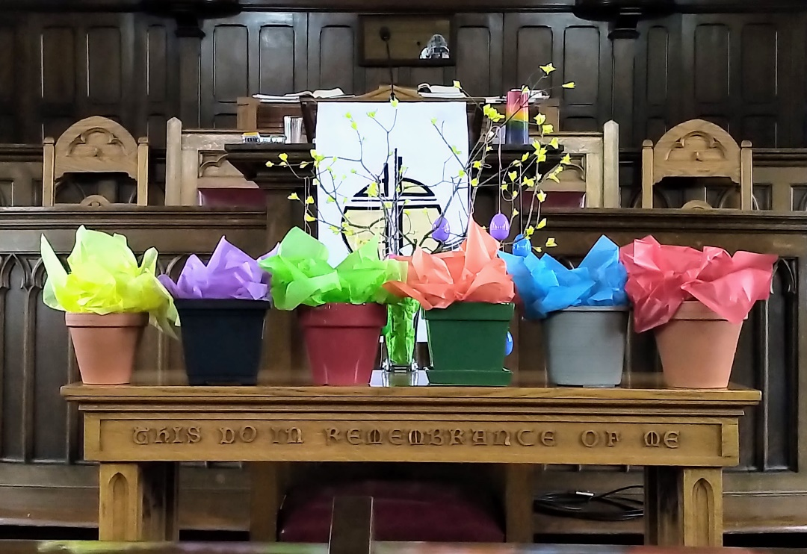

May 14, 2023 @ 10:00 am


181 Portland Street
Dartmouth
B2Y 1J5
902-464-8852

▲Rise in body or in spirit/ Responses in bold

Gathering Music

Welcome & Introductions

Crossing the Threshold Into Easter

Lighting the Christ and Pride Candles

Sung Celebration – Rejoice in the Lord, Always # 249 (Twice)

Rejoice in the Lord always
and again I say rejoice! (clap, clap)
Rejoice in the Lord always
and again I say rejoice! (clap, clap)
Rejoice, rejoice,
and again I say rejoice! (clap, clap)
Rejoice, rejoice,
and again I say rejoice! (clap, clap)

Call to Worship

We come in faith.
We come in friendship.
We persevere through teamwork.
We rejoice in community.
We come, thankful for kindness.
We come, delighted to be together once again.
Come, let us worship!

▲Hymn – Sing Your Praise to God Eternal # 244

Opening Prayer (Together)

Holy one, so often we try and put you in a box.
A box that has been shaped by
our history, culture and upbringing.
You continue to surprise us,
by the people you gather with,
by the norms you challenge,
and by the hospitality you both gave and received.
Help us break free of our boxes.

Silent Prayer…

We turn to you,
knowing that you understand us,
forgive us, and love us like a Mother,
and so we pray with confidence and faith,
“Our Father, who art in heaven,
hallowed be thy name; thy kingdom come;
thy will be done; on earth as it is in heaven.
Give us this day our daily bread.
And forgive us our trespasses,
as we forgive those who trespass against us.
And lead us not into temptation;
but deliver us from evil.
For thine is the kingdom,
the power and the glory,
for ever and ever.
Amen.

Listening for God’s Word For Us Today

A Time of Wondering

An Ancient Word – John 10: 1-10

Reflection – Shepherds

Reflective Music

Responding to God’s Word

▲Hymn – The Lord’s My Shepherd – Page # 747

▲A New Creed – Page # 918

Minute for Mission

Sharing Our Gifts

Prayers of the People

The Life and Ministry of the Faith Community – Please See Insert

Threshold Into God’s World

▲Hymn – Joy to the World # 59

▲Commissioning & Blessing

▲Song of Dismissal – Onward Easter People

Onward Easter people, risen with our Lord.
Loving, caring, sharing, spread his living Word.
Death no longer holds him, we can plainly see.
Christ is resurrected, we have been set free.
Onward Easter people, risen with our Lord.
Loving, caring, sharing, spread his living Word.

Music Takes Us into the World

~~~~~~~~~~~~~~~~~~~~~~~~~~~~~~~~~~~~~~~~~~



Write your answers on the bulletin boards in the Lower Hall!

Call to Worship -Catherine MacDonald – Based on Core Values Workshop – April 2023
Opening Prayer – Catherine MacDonald
Onward Easter People – Catherine MacDonald

