St. James United Church

Easter Series: Unearthing Joy

Joy & Doubt!

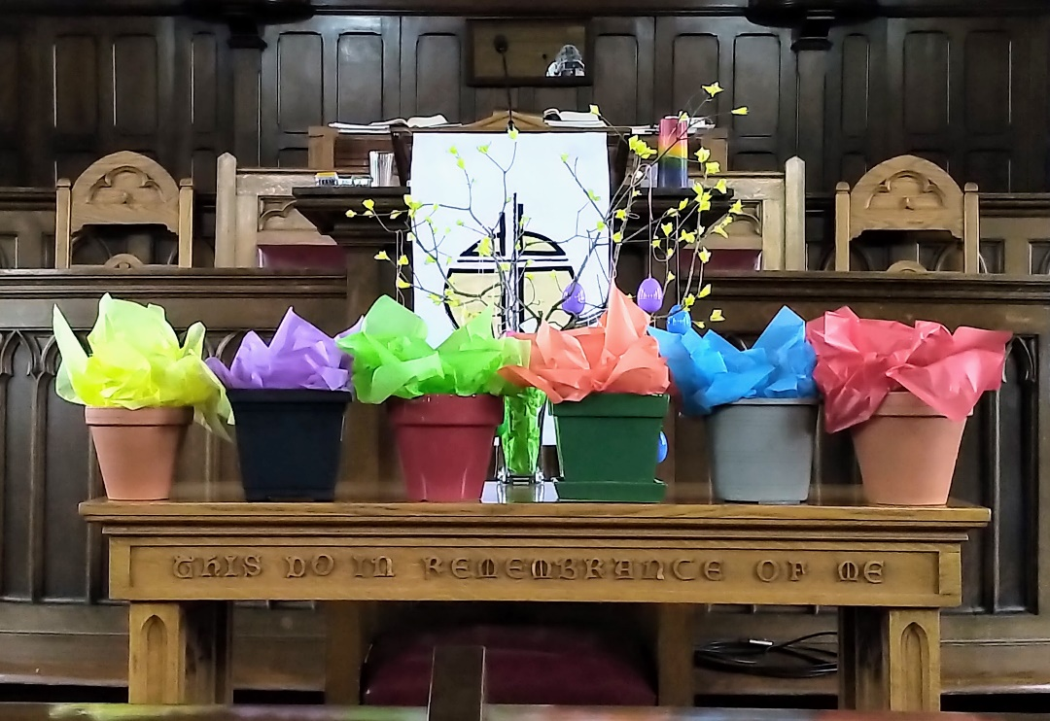

Earth Day

April 23, 2023 @ 10:00 am


181 Portland Street
Dartmouth
B2Y 1J5
902-464-8852

▲Rise in body or in spirit/ Responses in bold

Gathering Music

Welcome & Introductions

Crossing the Threshold Into Easter

Lighting the Christ and Pride Candles

Sung Celebration – Rejoice in the Lord, Always # 249

Rejoice in the Lord always
and again I say rejoice! (clap, clap)
Rejoice in the Lord always
and again I say rejoice! (clap, clap)
Rejoice, rejoice,
and again I say rejoice! (clap, clap)
Rejoice, rejoice,
and again I say rejoice! (clap, clap)

Call to Worship

We gather today with hearts full of doubt, uncertain about what lies ahead and unsure about the path we should take.
We come with questions and fears, hoping to find answers and comfort in this sacred space.
Doubt can be a heavy burden to bear, but it can also be a catalyst for growth and transformation.
We embrace our doubts, knowing that they can lead us to a deeper understanding of ourselves and our faith.
Let us open ourselves to the mystery and uncertainty of life, trusting that we will find the strength and courage
to face whatever comes our way.
May this time of worship be a source of inspiration and hope, as we seek to navigate the twists and turns of our journey with grace and humility. Amen.

▲Hymn – Come to My Heart, Lord Jesus # 661

Words of Assurance

Prayer of Confession (Together)

Compassionate God,
we are at the end of Earth Week,
and we come before you with heavy hearts.
We confess that we have ignored the signs of climate change, pollution, and destruction of natural resources.
We have taken your creation for granted and
exploited it for our own selfish desires.
We have failed to be good stewards of the earth,
and we ask for your forgiveness
for the damage we have caused.
We ask for your guidance in finding ways
to protect and preserve the earth,
so that future generations may enjoy the beauty and abundance of your creation.
Help us to overcome our doubts
and trust in your wisdom and grace.
Give us the courage to take action,
to live more sustainably,
and to advocate for policies that protect our planet.
May we be mindful of the impact of our choices
and seek to live in harmony with your creation.

Silent Prayer…

We turn to you,
knowing that you understand us,
forgive us, and love us like a Mother,
and so we pray with confidence and faith,
“Our Father, who art in heaven,
hallowed be thy name; thy kingdom come;
thy will be done; on earth as it is in heaven.
Give us this day our daily bread.
And forgive us our trespasses,
as we forgive those who trespass against us.
And lead us not into temptation;
but deliver us from evil.
For thine is the kingdom,
the power and the glory,
for ever and ever.
Amen.
Listening for God’s Word For Us Today

A Time of Wondering

An Ancient Word – John 20: 19-31

Reflection – Facing Our Doubts
Reflective Music

Responding to God’s Word

Minute for Mission

▲A New Creed – Page 918

▲Hymn – In the Bulb # 703

Sharing Our Gifts

Kneading our Doubts into Prayers

The Life and Ministry of the Faith Community – Please See Insert

Threshold Into God’s World

▲Hymn – Joyful, Joyful, We Adore You # 232

▲Commissioning & Blessing

▲Song of Dismissal – Onward Easter People

Onward Easter people, risen with our Lord.
Loving, caring, sharing, spread his living Word.
Death no longer holds him, we can plainly see.
Christ is resurrected, we have been set free.
Onward Easter people, risen with our Lord.
Loving, caring, sharing, spread his living Word.

Music Takes Us into the World

Call to Worship & Prayer of Confession – Catherine MacDonald
Onward Easter People – Catherine MacDonald

