St. James United Church

Who Are You Looking For?

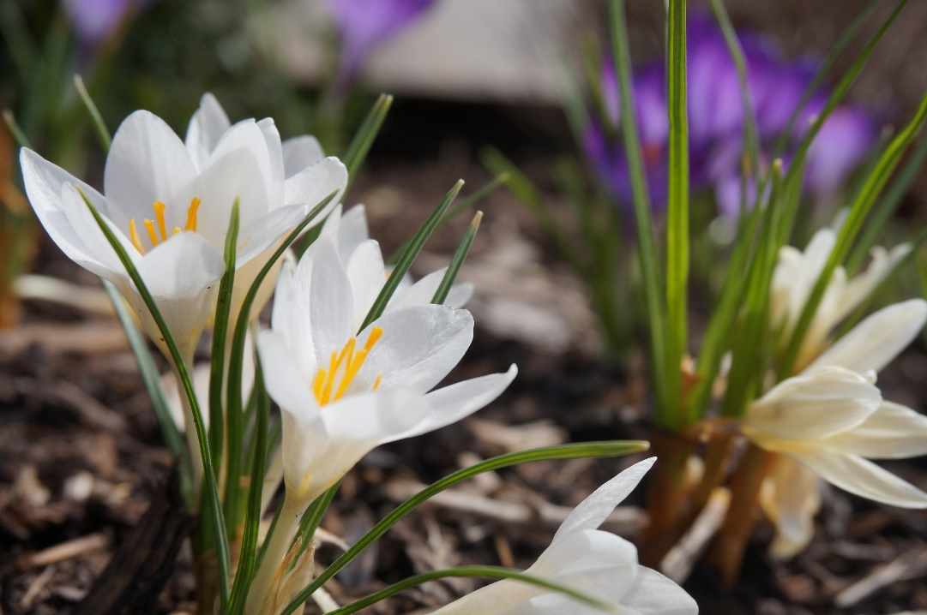

April 9, 2023 @ 10:00 am


181 Portland Street
Dartmouth
B2Y 1J5
902.464.8852

▲Rise in body or in spirit/ Responses in bold

Gathering Music

Welcome & Introductions

Crossing the Threshold Into Easter

Lighting the Christ and Pride Candles

Sung Celebration (Introit) – Rejoice in the Lord, Always # 249

Rejoice in the Lord always
and again I say rejoice! (clap, clap)
Rejoice in the Lord always
and again I say rejoice! (clap, clap)
Rejoice, rejoice,
and again I say rejoice! (clap, clap)
Rejoice, rejoice,
and again I say rejoice! (clap, clap)

Call to Worship

What are you looking for?
The light before dawn.
What are you looking for?
A reason to hope.
What are you looking for?
Joy after grief and flowers after winter.
What are you looking for?
A place to belong.
What are you looking for?
We are looking for the Messiah.
Good news! Come in. Love is alive!
Surely God is in this place.
Come, let us worship!

▲Hymn – Jesus Christ Is Risen Today # 155

Words of Assurance

Prayer of Confession (Together)

God of resurrection,
We confess, like a dog with a bone,
we run aimlessly.
We chase our tails,
looking for things that provide answers
to the suffering of the world,
looking for comfort to our longest nights.
You meet us in the darkness before dawn,
but we mistake you for the gardener.
Forgive us for seeking after worldly things.
Forgive us for forgetting to seek you.
Speak to us.
Call us by name,
that we might recognize you in our midst.
With hope and gratitude we pray, amen.

Listening for God’s Word For Us Today

Ministry of Music – Shine the Light

A Time of Wondering

An Ancient Word – John 20: 1-18

Reflection – Resurrection Is!
Reflective Music

Responding to God’s Word

The Sacrament of Communion

The Invitation

▲Passing of the Peace

▲Communion Hymn (Tune – This is My Father’s World)

Who are you looking for?
A body in the tomb?
The grave is death but God has breath
The Spirit’s wings need room
Who are you looking for?
He is not here but raised
The empty tomb is now a womb
Christ lives! Let God be praised!

Who are you looking for?
The man of Galilee?
He is not here but always near
Lift up your head and see
Who are you looking for?
Your rabbi and your friend
Is God in flesh who conquered death
Whose reign is without end

Who are you looking for?
An answer to pin down?
We cannot know where God will go
But seeking we are found
Who are you looking for?
God will not be boxed in
What we have found is love unbound
Dynamic as the wind.

The Great Thanksgiving

Resurrecting God,
Mary went to the garden looking for you.
Two thousand years later, we follow in her footsteps.

We seek after you,
hungry for a garden moment
where we might hear you say our name
or feel you in our midst.

So before the hallelujahs begin,
we empty our pockets of our prayers
and remember where we’ve been.
With gratitude, we recall Maundy Thursday.
We are grateful for the tables we gather around,
for the friends that feel like family,
and for this church—which acts as our band of disciples.
We hold onto the reminder of you
washing the disciples’ feet that night,
and trust that that same love extends to us.

With sorrow, we recall Good Friday.
We grieve the depths of cruelty woven into that day—
a cruelty so many in this hurting world know.
So, for those who are still caught in grief and loss,
for those whose days have turned to night,
relieve them of their suffering.
Find them in the crowd.
Wipe their tears.
Hold their grief for them
and point them toward peace.

Now, with hope we enter into this Easter morning,
to find ourselves face-to-face with your good news.
Thank you for giving us reason to hope.
Thank you for the sunrise after a long night,
for the healing of bones and hearts,
for laughter that is contagious,
and for the joy felt in community.
Tether every gratitude and joy in our life back to you.

And now, as we come to the Table,
just as Mary came to the tomb,
we ask that in every stage of our seeking,
you would be near to us.

Pour out your Spirit on this bread and cup
that we might see you as clearly as Mary did.
And may this meal nourish us to build your kin-dom here.

God of resurrection,
Mary went to the garden looking for you.
Two thousand years later,
we follow in her footsteps.
We seek after you,
hungry to hear you say our name.
So hold all of our prayers in your hearts,
and continue to reveal yourself in this broken world.
Until God’s promised day, we will sing, “Alleluia!”
We will hold onto hope.
We will seek you all of our days,
And we will pray the words
your Son taught us to pray,
Our Father, who art in heaven,
hallowed be thy name;
thy kingdom come;
thy will be done;
on earth as it is in heaven.
Give us this day our daily bread.
And forgive us our trespasses,
as we forgive those who trespass against us.
And lead us not into temptation;
but deliver us from evil.
For thine is the kingdom,
the power and the glory,
for ever and ever.
Amen.

Breaking, Pouring, Serving

Hymn During Communion # 466

Eat this bread, drink this cup;
come to me and never be hungry.
Eat this bread, drink this cup;
trust in me and you will not thirst.
(Continue until everyone is served)

Communion is Served)
(Our bread is gluten free)

Prayer Following Communion

Where don’t we seek after you, God?
We look for you in the mirror, in strangers,
in sunrises, on mountain tops,
in the laughter of children,
and in meals shared together.
We look for you on the city streets,
in hospital rooms, in jail cells,
in poetry, and hymn melodies.
We look for you everywhere!
Sometimes the seeking is hard,
but then at other times,
we come to this Table
and all are fed,
and all are welcomed,
and there is room for everyone,
and no one is turned away,
or made to feel unworthy.
And in those moments,
we see you clearly.
So thank you for meeting us in our seeking.
Please don’t stop seeking us.
Gratefully we pray,
amen.

▲Affirmation of Faith (Together)

We believe in resurrection.
mysterious, beyond our understanding,
and yet, like tulips after the snow: real.
We believe in Easter morning
in the promise of a God
who would roll back every stone
to return to us.
We believe in Jesus
who calls us by name and asks,
“Who are you looking for?”
So we look for justice, for mercy, for God in our midst.
And as we look, we sing, “Alleluia!” Amen.

Sharing Our Gifts

The Life and Ministry of the Faith Community – Please See Insert

Threshold Into God’s World

▲Hymn – The Day of Resurrection # 164

▲Commissioning & Blessing

▲Song of Dismissal – Onward Easter People

Onward Easter people, risen with our Lord.
Loving, caring, sharing, spread his living Word.
Death no longer holds him, we can plainly see.
Christ is resurrected, we have been set free.
Onward Easter people, risen with our Lord.
Loving, caring, sharing, spread his living Word.

Music Takes Us into the World



Liturgy – Seeking – A Sanctified Art
Shines the Light – Words: Susan Naus Dengler, Music: Lee Dengler
Who Are You Looking For – Anna Strickland
Onward Easter People – Catherine MacDonald

